**In-class Exercises**

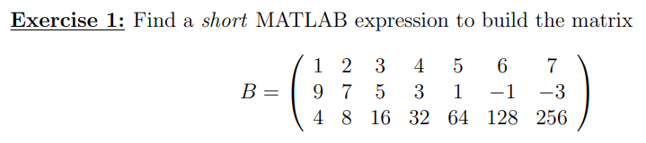

**Exercise 2:**

Given the following vectors and matrices

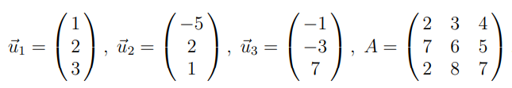

1. Matlab Structures

(a) Enter these data into Matlab.

(b) Calculate.

(c) Calculate the dot product between the vectors  and .

(d) Calculate the product .

2. Matlab Commands

Find the Matlab commands allowing you to:

(a) calculate 

(b) determine the dimensions of the matrix A, extract the number of columns;

(c) calculate the determinant and the inverse of A.

3. Resolution of linear systems

Propose two methods for solving the problem , and determine the associated Matlab commands

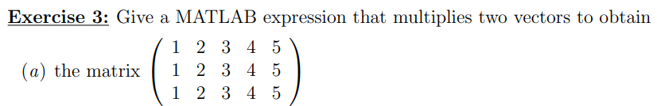

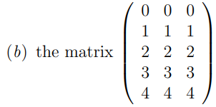

**Exercise 4:** Write a script/function that splits following sentence into individual words

**Exercise 5:** Create so called tokenizer (text analyzer), that

+ reads a text input str entered by user using function input,

+ reads separator sep (space requires some care),

+ split str into individual parts depending on sep,

+ store individual parts separately in a variable of type cell,

+ analyze how many vowels(a/e/i/y/o/u) each individual word contains, store this number and display it together with list of all individual words, + all commands in the whole script/function have to be terminated with a semicolon.

**Exercise 6:** Try to create simple unit converter, length x in 'mm', 'cm', 'in', 'inch' (variable units), length in inches can be marked as 'in' or 'inch'. Length will be transformed into [mm] according to entered unit string.

+ What decision making construct are you going to use?

+ Add a statement from which unit the length was converted and what the result is.